1. **Design a calculator for Windows CE.NET.**

**Coding :-**

using System;

using System.Collections.Generic;

using System.ComponentModel;

using System.Data;

using System.Drawing;

using System.Text;

using System.Windows.Forms;

namespace Calculator

{

public partial class Form1 : Form

{

double op1, op2, ans;

string str;

int len, oprator;

public Form1()

{

InitializeComponent();

}

private void button2_Click(object sender, EventArgs e)

{

if (textBox1.Text == "0" || textBox1.Text == "+" || textBox1.Text == "-" || textBox1.Text == "*" || textBox1.Text == "/" || textBox1.Text == "%")

textBox1.Text = "2";

else

textBox1.Text = textBox1.Text + "2";

}

private void button1_Click(object sender, EventArgs e)

{

if (textBox1.Text == "0" || textBox1.Text == "+" || textBox1.Text == "-" || textBox1.Text == "*" || textBox1.Text == "/" || textBox1.Text == "%")

textBox1.Text = "1";

else

textBox1.Text = textBox1.Text + "1";

}

private void button3_Click(object sender, EventArgs e)

{

if (textBox1.Text == "0" || textBox1.Text == "+" || textBox1.Text == "-" || textBox1.Text == "*" || textBox1.Text == "/" || textBox1.Text == "%")

textBox1.Text = "3";

else

textBox1.Text = textBox1.Text + "3";

}

private void button13_Click(object sender, EventArgs e)

{

op1 = Convert.ToDouble(textBox1.Text);

textBox1.Text = "/";

oprator = 1;

}

private void button5_Click(object sender, EventArgs e)

{

if (textBox1.Text == "0" || textBox1.Text == "+" || textBox1.Text == "-" || textBox1.Text == "*" || textBox1.Text == "/" || textBox1.Text == "%")

textBox1.Text = "5";

else

textBox1.Text = textBox1.Text + "5";

}

private void button6_Click(object sender, EventArgs e)

{

if (textBox1.Text == "0" || textBox1.Text == "+" || textBox1.Text == "-" || textBox1.Text == "*" || textBox1.Text == "/" || textBox1.Text == "%")

textBox1.Text = "6";

else

textBox1.Text = textBox1.Text + "6";

}

private void button4_Click(object sender, EventArgs e)

{

if (textBox1.Text == "0" || textBox1.Text == "+" || textBox1.Text == "-" || textBox1.Text == "*" || textBox1.Text == "/" || textBox1.Text == "%")

textBox1.Text = "4";

else

textBox1.Text = textBox1.Text + "4";

}

private void button7_Click(object sender, EventArgs e)

{

if (textBox1.Text == "0" || textBox1.Text == "+" || textBox1.Text == "-" || textBox1.Text == "*" || textBox1.Text == "/" || textBox1.Text == "%")

textBox1.Text = "7";

else

textBox1.Text = textBox1.Text + "7";

}

private void button8_Click(object sender, EventArgs e)

{

if (textBox1.Text == "0" || textBox1.Text == "+" || textBox1.Text == "-" || textBox1.Text == "*" || textBox1.Text == "/" || textBox1.Text == "%")

textBox1.Text = "8";

else

textBox1.Text = textBox1.Text + "8";

}

private void button9_Click(object sender, EventArgs e)

{

if (textBox1.Text == "0" || textBox1.Text == "+" || textBox1.Text == "-" || textBox1.Text == "*" || textBox1.Text == "/" || textBox1.Text == "%")

textBox1.Text = "9";

else

textBox1.Text = textBox1.Text + "9";

}

private void button10_Click(object sender, EventArgs e)

{

if (textBox1.Text == "0" || textBox1.Text == "+" || textBox1.Text == "-" || textBox1.Text == "*" || textBox1.Text == "/" || textBox1.Text == "%")

textBox1.Text = "0";

else

textBox1.Text = textBox1.Text + "0";

}

private void button11_Click(object sender, EventArgs e)

{

if (textBox1.Text == "0" || textBox1.Text == "+" || textBox1.Text == "-" || textBox1.Text == "*" || textBox1.Text == "/" || textBox1.Text == "%")

textBox1.Text = "0";

else

textBox1.Text = textBox1.Text + "00";

}

private void button19_Click(object sender, EventArgs e)

{

op1 = Convert.ToDouble(textBox1.Text);

textBox1.Text = "%";

oprator = 5;

}

private void button20_Click(object sender, EventArgs e)

{

op2 = Convert.ToDouble(textBox1.Text);

switch (oprator)

{

case 1:

ans = op1 / op2;

break;

case 2:

ans = op1 * op2;

break;

case 3:

ans = op1 + op2;

break;

case 4:

ans = op1 - op2;

break;

case 5:

ans = (op1 * 100) / op2;

break;

}

textBox1.Text = Convert.ToString(ans);

}

private void button14_Click(object sender, EventArgs e)

{

op1 = Convert.ToDouble(textBox1.Text);

textBox1.Text = "*";

oprator = 2;

}

private void button15_Click(object sender, EventArgs e)

{

op1 = Convert.ToDouble(textBox1.Text);

textBox1.Text = "+";

oprator = 3;

}

private void button16_Click(object sender, EventArgs e)

{

op1 = Convert.ToDouble(textBox1.Text);

textBox1.Text = "-";

oprator = 4;

}

private void button17_Click(object sender, EventArgs e)

{

len = textBox1.Text.Length;

if (len != 0)

str = textBox1.Text.Remove(len - 1, 1);

else

textBox1.Text = "0";

textBox1.Text = str;

}

private void Form1_Load(object sender, EventArgs e)

{

textBox1.Text = "0";

}

private void button12_Click(object sender, EventArgs e)

{

if (textBox1.Text == "0" || textBox1.Text == "+" || textBox1.Text == "-" || textBox1.Text == "*" || textBox1.Text == "/" || textBox1.Text == "%")

{ textBox1.Text = "0."; }

else

{

textBox1.Text = textBox1.Text + ".";

}

}

private void button18_Click(object sender, EventArgs e)

{

textBox1.Text = "0";

}

}

}

**Output :-**

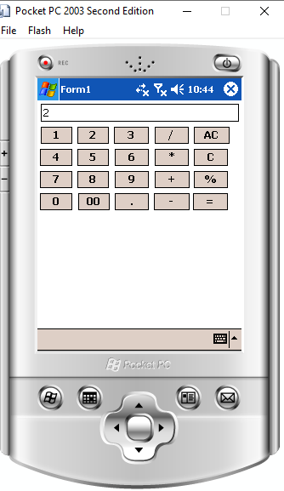 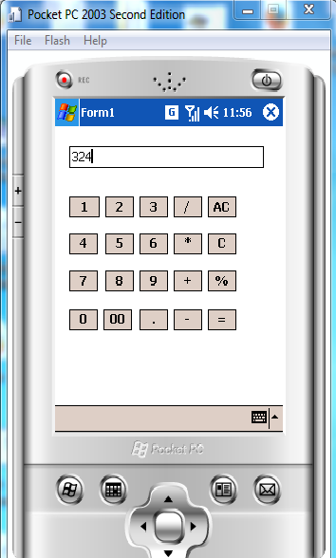

1. **Write a program for menu driven Smartphone application to display formula for calculation for area for various shapes should be selected from menu (square, triangle, rectangle and circle).**

**Coding :-**

using System;

using System.Collections.Generic;

using System.ComponentModel;

using System.Data;

using System.Drawing;

using System.Text;

using System.Windows.Forms;

namespace Area_Shapes

{

public partial class Form1 : Form

{

Single hei, bs, rad, wid, hi, sid;

int num;

public Form1()

{

InitializeComponent();

}

private void label2_ParentChanged(object sender, EventArgs e)

{

}

private void label3_ParentChanged(object sender, EventArgs e)

{

}

private void menuItem2_Click(object sender, EventArgs e)

{

num = 1;

lblHeight.Visible = true;

lblBase.Visible = true;

txtHeight.Visible = true;

txtBase.Visible = true;

txtHeight.Text = "";

txtBase.Text = "";

txtArea.Text = "";

txtHeight.Focus();

}

private void menuItem3_Click(object sender, EventArgs e)

{

num = 2;

lblHeight.Visible = true;

lblHeight.Text = "width";

lblBase.Visible = true;

lblBase.Text = "height";

txtHeight.Visible = true;

txtBase.Visible = true;

txtHeight.Text = "";

txtBase.Text = "";

txtArea.Text = "";

txtHeight.Focus();

}

private void menuItem4_Click(object sender, EventArgs e)

{

num = 3;

lblHeight.Visible = true;

lblHeight.Text = "Radius";

lblBase.Visible = false;

lblHeight.Visible = true;

txtHeight.Visible = true;

txtBase.Visible = false;

txtHeight.Text = "";

txtBase.Text = "";

txtArea.Text = "";

txtHeight.Focus();

}

private void menuItem5_Click(object sender, EventArgs e)

{

num = 4;

lblHeight.Visible = true;

lblHeight.Text = "side";

// lblHeight.Visible = true;

txtHeight.Visible = true;

// txtBase.Visible = false;

txtHeight.Text = "";

// txtBase.Text = "";

txtArea.Text = "";

txtHeight.Focus();

}

private void menuItem6_Click(object sender, EventArgs e)

{

switch (num)

{

case 1:

bs = Convert.ToSingle(txtBase.Text);

hei = Convert.ToSingle(txtHeight.Text);

txtArea.Text = ((1 / 2) * bs * hei).ToString();

break;

case 3:

rad = Convert.ToSingle(txtHeight.Text);

//hei = Convert.ToSingle(txtHeight.Text);

txtArea.Text = (Math.PI * rad * rad).ToString();

break;

case 4:

sid = Convert.ToSingle(txtHeight.Text);

txtArea.Text = (sid * sid).ToString();

break;

case 2:

wid = Convert.ToSingle(txtBase.Text);

hi = Convert.ToSingle(txtHeight.Text);

txtArea.Text = (wid * hi).ToString();

break;

default:

txtArea.Text = "";

break;

}

}

}

}

**Output :-**

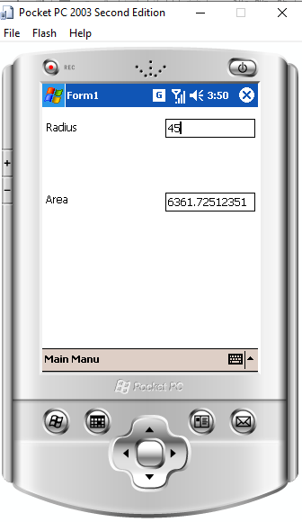

1. **Design a file viewer for windows CE.Net.**

**Coding:-**

using System;

using System.Collections.Generic;

using System.ComponentModel;

using System.Data;

using System.Drawing;

using System.Text;

using System.Windows.Forms;

using System.Diagnostics;

namespace FileViewer

{

public partial class Form1 : Form

{

public Form1()

{

InitializeComponent();

}

private void btnRun_Click(object sender, EventArgs e)

{

Process p = new Process();

p.StartInfo.FileName = txtFileViewer.Text;

p.Start();

}

private void btnBrowse_Click(object sender, EventArgs e)

{

string FileName;

openFileDialog1.InitialDirectory = Environment.GetFolderPath(Environment.SpecialFolder.Personal);

openFileDialog1.Filter = openFileDialog1.Filter = "All Files(*.*)|*.*";

if (openFileDialog1.ShowDialog() == DialogResult.OK)

{

FileName = openFileDialog1.FileName;

txtFileViewer.Text = FileName;

}

}

}

}

**Output:-**

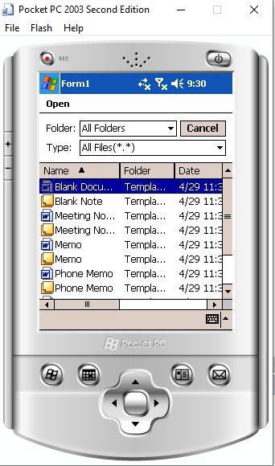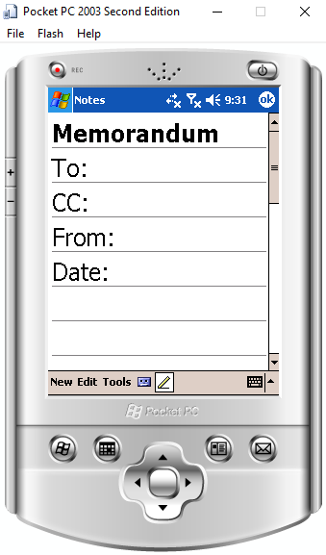

1. **Write a program for image viewer in smart device application.**

**Coding :-**

using System;

using System.Collections.Generic;

using System.ComponentModel;

using System.Data;

using System.Drawing;

using System.Text;

using System.Windows.Forms;

namespace Image_Viewer

{

public partial class Form1 : Form

{

int inc = 0;

int count = 0;

public Form1()

{

InitializeComponent();

}

private void menuItem1_Click(object sender, EventArgs e)

{

if (inc >= 0)

{

if (inc == count)

inc--;

pictureBox.Image = imageList.Images[inc];

if (inc == 0)

inc = 0;

else

inc--;

}

}

private void menuItem2_Click(object sender, EventArgs e)

{

if (inc <= count)

{

if (inc == 0)

inc++;

pictureBox.Image = imageList.Images[inc];

if (inc == count)

inc = count;

else

inc++;

}

}

private void pictureBox1_Click(object sender, EventArgs e)

{

}

private void Form1_Load(object sender, EventArgs e)

{

count = imageList.Images.Count - 1;

pictureBox.Image = imageList.Images[0];

inc++;

}

}

}

**Output :-**

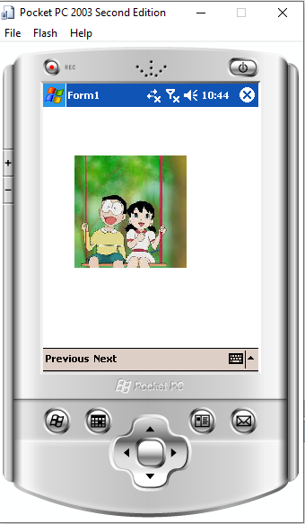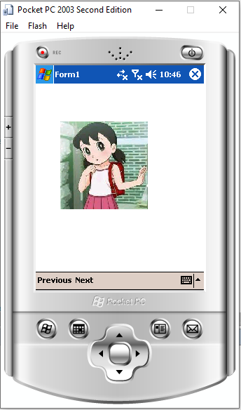

1. **Write a program to implement multithreading.**

**Coding :-**

using System;

using System.Collections.Generic;

using System.Text;

using System.Threading;

namespace ConsoleAppmultithreading

{

class Program

{

static void Main(string[] args)

{

Console.WriteLine("MultiThreading");

Thread tid1 = new Thread(new ThreadStart(MyThread.Thread1));

Thread tid2 = new Thread(new ThreadStart(MyThread.Thread2));

tid1.Start();

tid2.Start();

}

}

public class MyThread

{

public static void Thread1()

{

for (int i = 0; i < 10; i++)

{

Console.WriteLine("Thread1{0}", i);

}

}

public static void Thread2()

{

for (int i = 0; i < 10; i++)

{

Console.WriteLine("Thread2 {0}", i);

}

Console.ReadLine();

}

}

}

**Output :-**

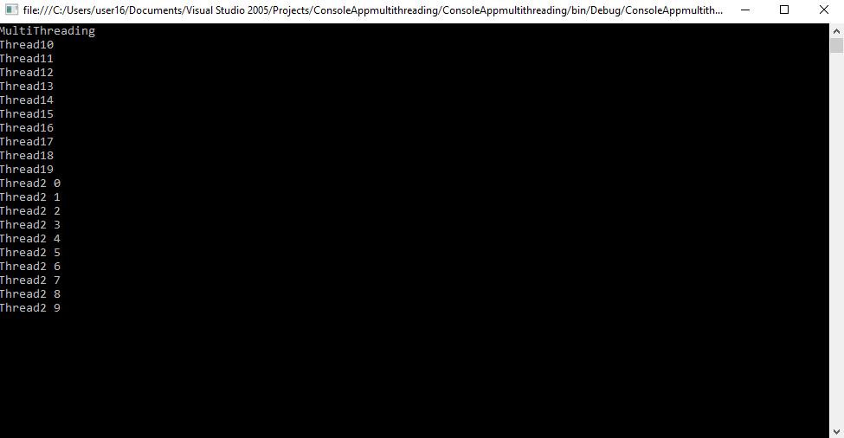

1. **Write a program to add data of two object using operator overloading.**

**Coding :-**

**Output :-**

1. **Write a menu driven Smartphones application to implement date picker to accept data of birth and display the current age.**

**Coding :-**

using System;

using System.Collections.Generic;

using System.ComponentModel;

using System.Data;

using System.Drawing;

using System.Text;

using System.Windows.Forms;

namespace Date_Picker

{

public partial class Form1 : Form

{

public Form1()

{

InitializeComponent();

}

private void dateTimePicker1_ValueChanged(object sender, EventArgs e)

{

DateTime curTime = DateTime.Now;

int yr, month, day;

DateTime bday;

bday = Convert.ToDateTime(dateTimePicker1.Value);

month = 12 * (DateTime.Now.Year - bday.Year) + (DateTime.Now.Month - bday.Month);

if (DateTime.Now.Day < bday.Day)

{

month -= 1;

day = DateTime.DaysInMonth(bday.Year, bday.Month) - bday.Day + DateTime.Now.Day;

}

else

{

day = DateTime.Now.Day - bday.Day;

}

yr = Convert.ToInt32(Math.Floor(month / 12));

month -= yr * 12;

label2.Text = yr + "year" + month + "Month" + day + "Days";

}

}

}

**Output :-**

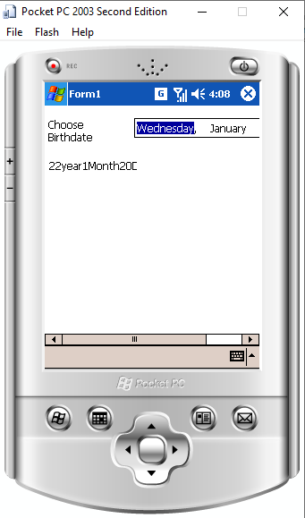

1. **Write a program in C# using datagates to printing the various formats of the strings.**

**Coding :-**

using System;

using System.Collections.Generic;

using System.ComponentModel;

using System.Data;

using System.Drawing;

using System.Text;

using System.Windows.Forms;

namespace String

{

public delegate string strDelegate(string s);

public partial class Form1 : Form

{

strDelegate sd;

public Form1()

{

InitializeComponent();

}

private void label4_ParentChanged(object sender, EventArgs e)

{

}

private void lowerBtn_Click(object sender, EventArgs e)

{

sd = new strDelegate(DelegateEx.AllChrLowerCAse);

label3.Text = sd.Invoke(textBox1.Text);

label2.Text = "LowerCase";

}

private void button2_Click(object sender, EventArgs e)

{

sd = new strDelegate(DelegateEx.StrReverse);

label3.Text = sd.Invoke(textBox1.Text);

label2.Text = "Reverse String";

}

private void uppercaseBtn_Click(object sender, EventArgs e)

{

sd = new strDelegate(DelegateEx.AllChrUpperCAse);

label3.Text = sd.Invoke(textBox1.Text);

label2.Text = "UpperCase";

}

private void button4_Click(object sender, EventArgs e)

{

sd = new strDelegate(DelegateEx.Encrypt);

label3.Text = sd.Invoke(textBox1.Text);

label2.Text = "Encrypted String";

}

private void button5_Click(object sender, EventArgs e)

{

sd = new strDelegate(DelegateEx.strremovespace);

label3.Text = sd.Invoke(textBox1.Text);

label2.Text = "After Removing Space";

}

}

class DelegateEx

{

public static string AllChrLowerCAse(string s)

{

string lower = s.ToLower();

return lower;

}

public static string AllChrUpperCAse(string s)

{

string upper = s.ToUpper();

return upper;

}

public static string StrReverse(string s)

{

int len = s.Length;

char[] arr = new char[len];

for (int i = 0; i < len; i++)

{

arr[i] = s[len - 1 - i];

}

return new string(arr);

}

public static string Encrypt(string s)

{

int len = s.Length, i = 0;

char[] str = new char[len];

string str1 = "";

while (i < len)

{

if (string.Compare(s[i].ToString(), str1) != 0)

str[i] = Convert.ToChar(Convert.ToInt32(s[i] + 100));

else

str[i] = ' ';

i++;

}

return new string(str);

}

public static string strremovespace(string s)

{

int len = s.Length, i = 0, j = 0;

char[] str = new char[len];

string str1 = " ";

while (i < len)

{

if (string.Compare(s[i].ToString(), str1) != 0)

{

str[j] = s[i];

j++;

}

i++;

}

return new string(str);

}

}

}

**Output :-**



1. **Write a Menu driven smartphones application to implement list box of select names of country and display the current time of selected control.**

**Coding :-**

using System;

using System.Collections.Generic;

using System.ComponentModel;

using System.Data;

using System.Drawing;

using System.Text;

using System.Windows.Forms;

namespace Current_Time

{

public partial class Form1 : Form

{

DateTime da;

DateTime dt = new DateTime();

DateTime dat;

int hr;

public Form1()

{

InitializeComponent();

}

private void label2_ParentChanged(object sender, EventArgs e)

{

}

private void label1_ParentChanged(object sender, EventArgs e)

{

}

private void comboBox1_SelectedIndexChanged(object sender, EventArgs e)

{

if ((textBox.Text == "22:15"))

{

dat = Convert.ToDateTime(dateTimePicker.Value);

da = Convert.ToDateTime(textBox.Text);

hr = da.Hour;

if (comboBox1.SelectedIndex == 0)

{

dt = da.AddHours(4).AddMinutes(30);

lblcou.Text = "Australia";

funnext();

}

if (comboBox1.SelectedIndex == 1)

{

dt = da.AddHours(4).AddMinutes(30);

lblcou.Text = "Bhutan";

funnext();

}

if (comboBox1.SelectedIndex == 2)

{

dt = da.AddHours(4).AddMinutes(30);

lblcou.Text = "Canada";

funbac();

}

if (comboBox1.SelectedIndex == 3)

{

dt = da.AddHours(4).AddMinutes(30);

lblcou.Text = "China";

funnext();

}

if (comboBox1.SelectedIndex == 4)

{

dt = da.AddHours(4).AddMinutes(30);

lblcou.Text = "France";

funbac();

}

if (comboBox1.SelectedIndex == 5)

{

dt = da.AddHours(0).AddMinutes(15);

lblcou.Text = "Nepal";

funnext();

}

if (comboBox1.SelectedIndex == 6)

{

dt = da.AddHours(0).AddMinutes(30);

lblcou.Text = "Pakistan";

funbac();

}

lblres.Text = "";

string str = dat.Month + "/" + dat.Day + "/" + dat.Year;

str = str + " " + dt.Hour.ToString() + ":" + dt.Minute.ToString();

lblres.Text = str;

}

else

textBox.Text = "";

}

public void funnext()

{

int a;

if (dt.Hour > hr)

a = dt.Hour - hr;

else

a = dt.Hour;

hr = hr + a;

if (hr >= 24)

dat = dat.AddDays(1);

}

public void funbac()

{

hr = hr - dt.Hour;

if (hr < 0)

dat = dat.AddDays(-1);

}

private void lblcou_ParentChanged(object sender, EventArgs e)

{

}

}

}

Output :-

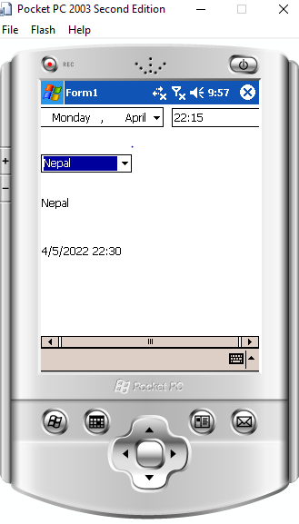

1. **Write a program to check weather the entered number is Armstrong Number or Not.**

**Coding :-**

using System.Collections.Generic;

using System.ComponentModel;

using System.Data;

using System.Drawing;

using System.Text;

using System.Windows.Forms;

namespace Armstrong

{

public partial class Form1 : Form

{

int num, rem, sum = 0;

public Form1()

{

InitializeComponent();

}

private void button1_Click(object sender, EventArgs e)

{

num = Convert.ToInt32(textBox1.Text);

for (int i = num; i > 0; i = i / 10)

{

rem = i % 19;

sum = sum + rem * rem * rem;

}

if (sum == num)

{

label2.Text = "Entered no. is an armstring no";

}

else

{

label2.Text = "Entered no. is not an armstrong no";

}

}

}

}

**Output :-**

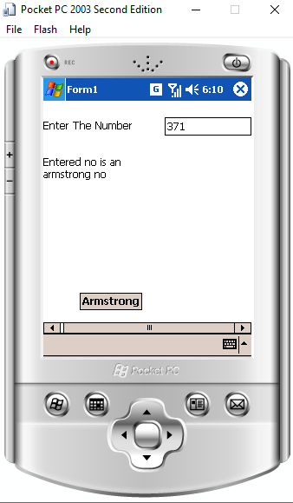

1. **Write a program to check whether the entered number is Prime or not.**

**Coding :-**

using System;

using System.Collections.Generic;

using System.ComponentModel;

using System.Data;

using System.Drawing;

using System.Text;

using System.Windows.Forms;

namespace DeviceApplicationPrimeNo

{

public partial class Form1 : Form

{

int num, k = 0;

public Form1()

{

InitializeComponent();

}

private void label1_ParentChanged(object sender, EventArgs e)

{

}

private void btnPrime_Click(object sender, EventArgs e)

{

num = Convert.ToInt32(textBox1.Text);

for (int i = 1; i <= num; i++)

{

if (num % i == 0)

{

k++;

}

}

if (k == 2)

{

label2.Text = "Entered no is prime no ";

}

else {

label2.Text = "Entered no is not prime no";

}

}

}

}

**Output :-**

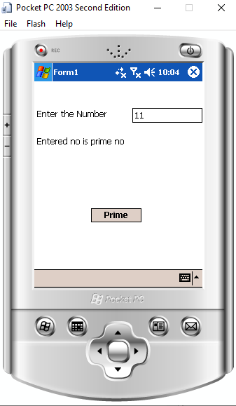

1. **Write a program for Sum of digit in smart device application.**

**Coding :-**

using System;

using System.Collections.Generic;

using System.ComponentModel;

using System.Data;

using System.Drawing;

using System.Text;

using System.Windows.Forms;

namespace Sum

{

public partial class Form1 : Form

{

int n, sum = 0, m;

public Form1()

{

InitializeComponent();

}

private void button1_Click(object sender, EventArgs e)

{

m = n % 10;

sum = sum + m;

n = n / 10;

label2.Text = "sum of Digit =" + sum;

}

}

}

**Output :-**

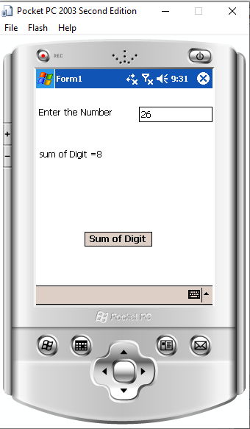

1. **Write a program to generate marksheet of student in smart device application.**

**Coding :-**

usingSystem;

using System.Collections.Generic;

using System.ComponentModel;

using System.Data;

using System.Drawing;

using System.Text;

using System.Windows.Forms;

namespace Marksheet

{

public partial class Form1 : Form

{

int r, m1, m2, m3, t;

float p;

string n;

public Form1()

{

InitializeComponent();

}

private void label3_ParentChanged(object sender, EventArgs e)

{

}

private void label4_ParentChanged(object sender, EventArgs e)

{

}

private void label2_ParentChanged(object sender, EventArgs e)

{

}

private void label7_ParentChanged(object sender, EventArgs e)

{

}

private void label5_ParentChanged(object sender, EventArgs e)

{

}

private void textBox5_TextChanged(object sender, EventArgs e)

{

}

private void button1_Click(object sender, EventArgs e)

{

r = Convert.ToInt32(textBox1.Text);

n = Convert.ToString(textBox2.Text);

m1 = Convert.ToInt32(textBox3.Text);

m2 = Convert.ToInt32(textBox4.Text);

m3 = Convert.ToInt32(textBox5.Text);

t = m1 + m2 + m3;

p = t / 3.0f;

label6.Text = "Total is : " + t;

label7.Text = "Percentage is : " + p;

}

}

}

**Output :-**

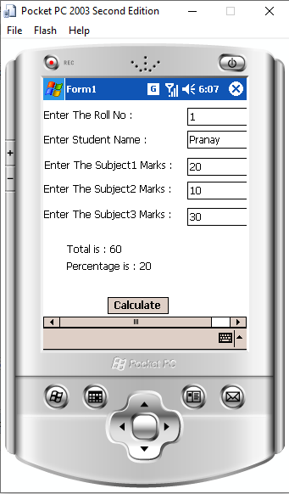

1. **Write a program to check weather the number is Palindrom or Not.**

**Coding :-**

using System;

using System.Collections.Generic;

using System.ComponentModel;

using System.Data;

using System.Drawing;

using System.Text;

using System.Windows.Forms;

namespace Palimdrome

{

public partial class Form1 : Form

{

int num, rem, sum = 0, temp;

public Form1()

{

InitializeComponent();

}

private void Form1_Load(object sender, EventArgs e)

{

}

private void button1_Click(object sender, EventArgs e)

{

num = Convert.ToInt32(textBox1.Text);

temp = num;

while (num > 0)

{

rem = num % 10;

num = num / 10;

sum = sum * 10 + rem;

}

label2.Text = "The Reversed Number is :" + sum;

if (temp == sum)

{

label3.Text = "The Number is Palindrome";

}

else

{

label3.Text = "The Number is Not Palindrome";

}

}

}

}

Output :-

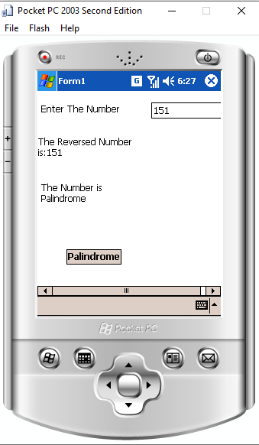

1. **Write a Program in a smart device application in C# to demonstrate the difference between prefix and Postfix form of ++.**

**Coding :-**

using System;

using System.Collections.Generic;

using System.ComponentModel;

using System.Data;

using System.Drawing;

using System.Text;

using System.Windows.Forms;

namespace Prefix

{

public partial class Form1 : Form

{

int x;

int[] y = new int[10];

int i;

public Form1()

{

InitializeComponent();

}

private void button1_Click(object sender, EventArgs e)

{

x = 1;

for (i = 0; i < 10; i++)

{

y[i] = x + ++x;

}

txtprefix.Text = y[0] + " " + y[1] + " " + y[2] + " " + y[3] + " " + y[4] + " " + y[5] + " " + y[6] + " " + y[7] + " " + y[8] + " " + y[9] + " ";

}

private void button2_Click(object sender, EventArgs e)

{

x = 1;

for (i = 0; i < 10; i++)

{

y[i] = x + (x++);

}

txtpostfix.Text = y[0] + " " + y[1] + " " + y[2] + " " + y[3] + " " + y[4] + " " + y[5] + " " + y[6] + " " + y[7] + " " + y[8] + " " + y[9] + " ";

}

}

}

**Output :-**

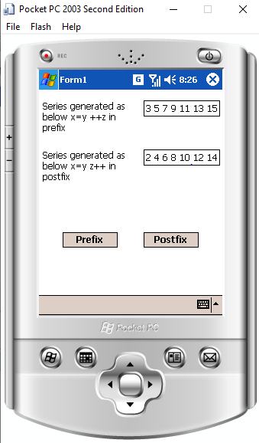

1. **Write a program to create database and display table in data grid control by using database connectivity.**

**Coding :-**

**Output :-**

1. **Write a program for mouse event handling as Smart Device Application.**

**Coding :-**

using System;

using System.Collections.Generic;

using System.ComponentModel;

using System.Data;

using System.Drawing;

using System.Text;

using System.Windows.Forms;

namespace Mouse_Handler

{

public partial class Form1 : Form

{

int x, y;

public Form1()

{

InitializeComponent();

}

private void Form1_Load(object sender, EventArgs e)

{

}

private void Form1_MouseDown(object sender, MouseEventArgs e)

{

x = MousePosition.X;

y = MousePosition.Y;

lblmessage.Text = "MOUSE DOWN EVENT OCCURED POSITION:" + x + "" + y;

}

private void Form1_MouseMove(object sender, MouseEventArgs e)

{

x = MousePosition.X;

y = MousePosition.Y;

lblmessage.Text = "MOUSE MOVE EVENT OCCURED POSITION:" + x + "" + y; }

private void Form1_MouseUp(object sender, MouseEventArgs e)

{

x = MousePosition.X;

y = MousePosition.Y;

lblmessage.Text = "MOUSE UP EVENT OCCURED POSITION:" + x + "" + y;

}

}

}

**Outpu :-**

